For our project, we have decided to make a shoot-em-up game. In this kind of game, the player controls someone or something that has to shoot other things while the camera scrolls in different direcctions. Examples of games in this genre are Capcoms's 1942, Konami's R-Type, and Taito's Space Invaders; which scrolled the screen vertically in 1942 and horizontally in R-Type, while Space Invaders had a static viewpoint.

Before developing a prototype, we made a questionnaire that we sent to the whole school about the game. The questions were:
- Have you played a shoot-em-up game?
- If so, how many?
- Do you prefer shoot-em-up games that scroll horizontally, vertically, or not at all?
- Do you prefer short games or long games?
- Do you prefer games with cartoony art styles or realistic art styles?
- Do you like games with role-playing elements? (For example, you get experience from killing enemies which you can use after you die)
- What place would you like the game to take place in?
When we got our results, we tallied them up and these were the results:
For the scrolling direction, horizontal was chosen with 32% of the votes
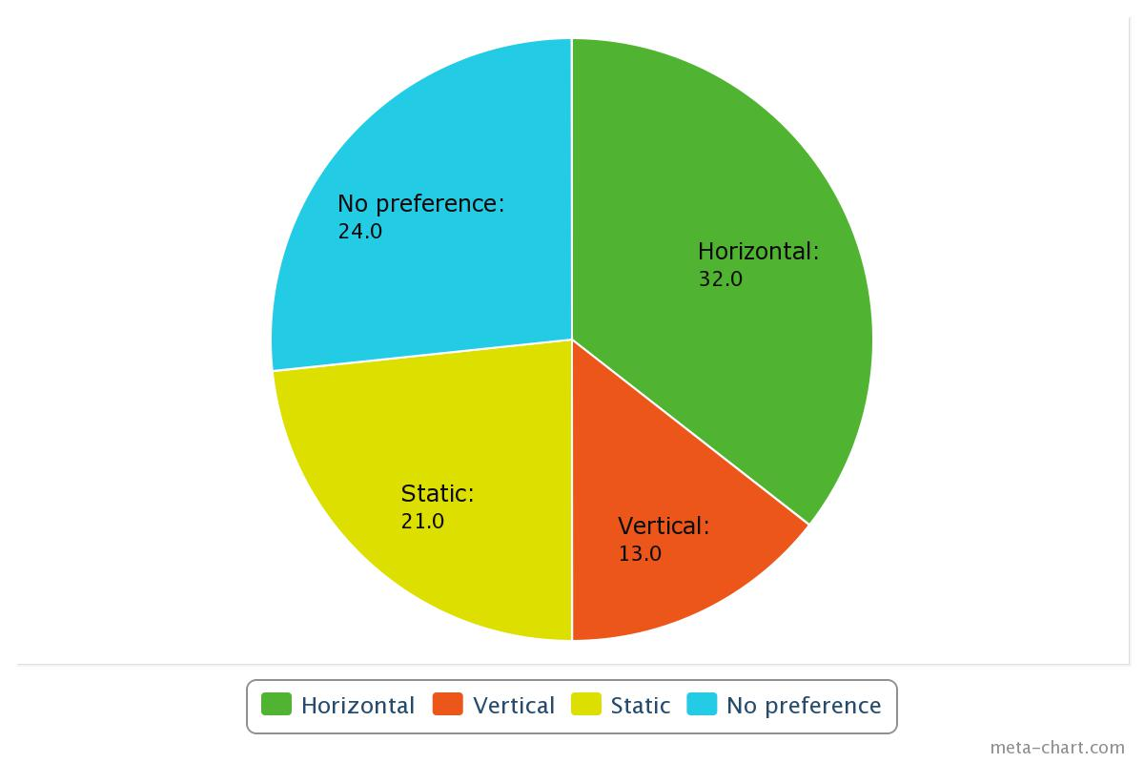
For the length, short was chosen with 66%. This means the game will be able to be completed in about half an hour.
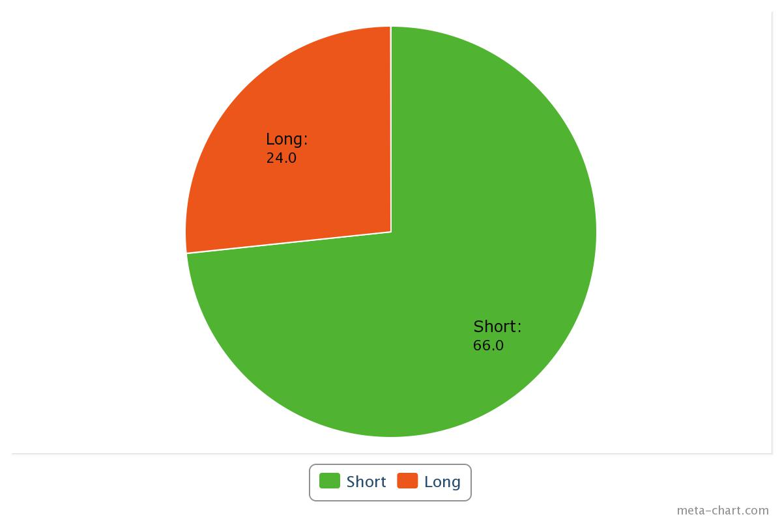

For the art style, realistic was chosen with 53%
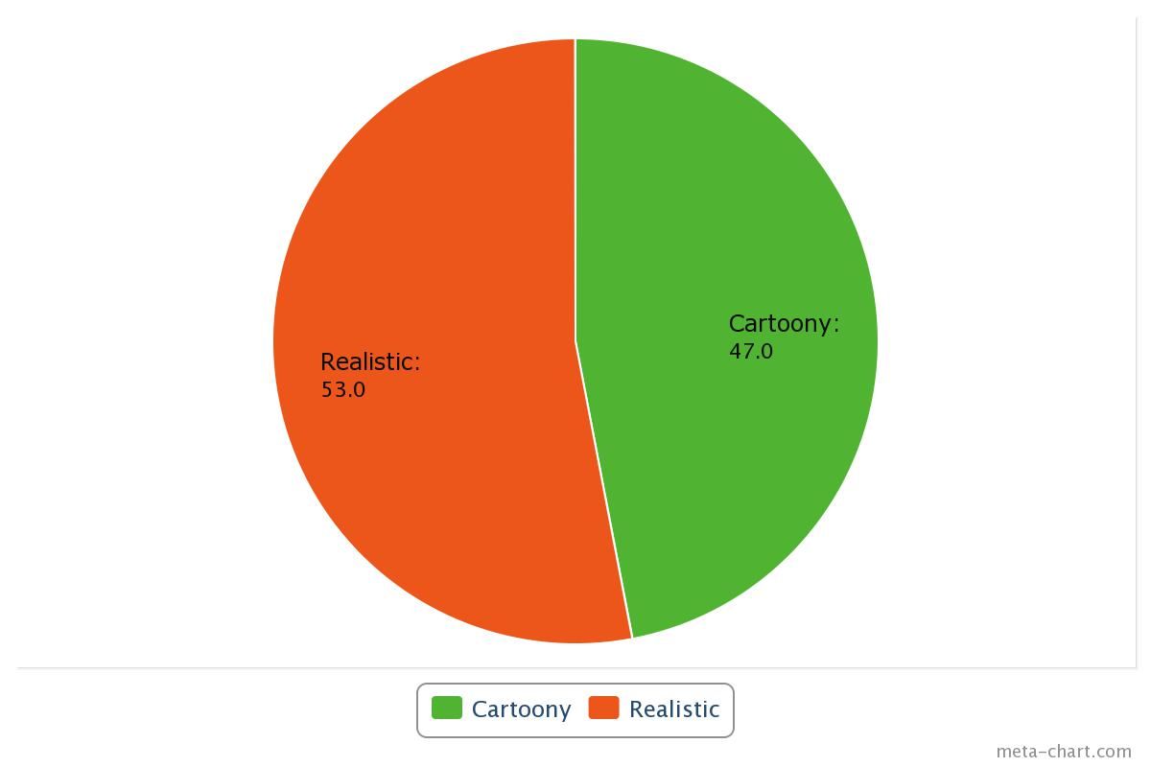
For whether the game should have RPG elements, yes was chosen with 63%
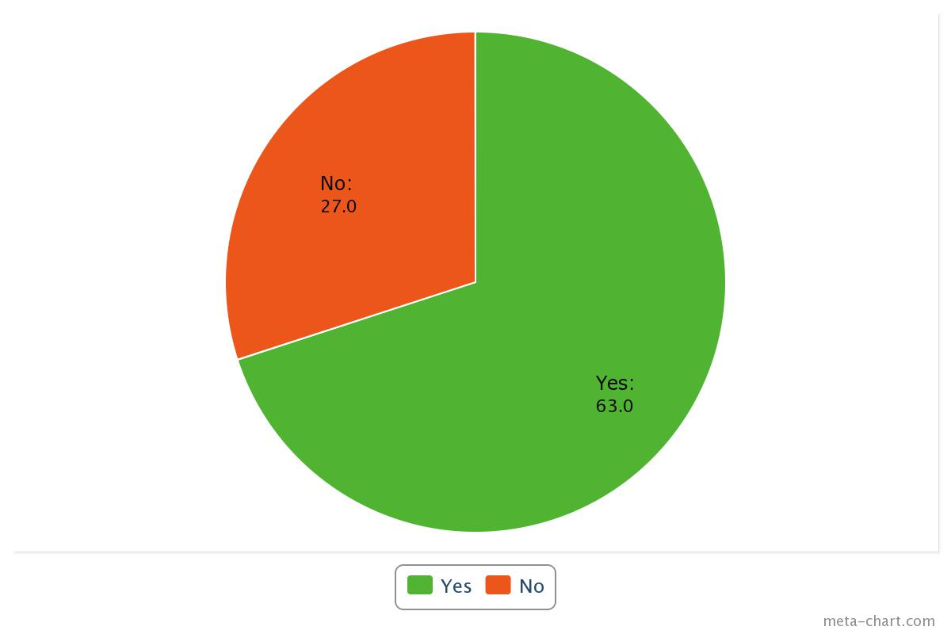
And for location, land was chosen with 37%, with space coming in just behind at 30%.
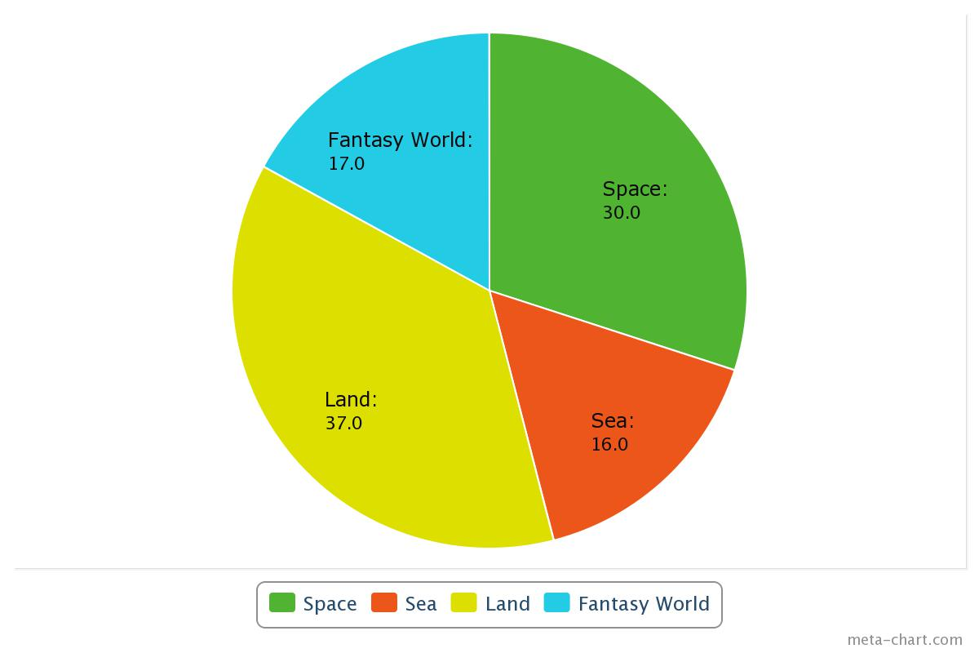
So the game will be a short horizontally scrolling shooter with a realistic art style and RPG elements set on land. Good to know.

Next, we need to deicide if this project is feasible. First, we need to decide what products to use. To actually make the game, we can decide between GameMaker, Unity, or programming the game without any external applications. Because the art style will need to look somewhat realistic, I think we should use Unity; because GameMaker can only use sprites, which makes it hard to look realistic because of the limited number of pixels you can use. Unity also doesn't have any limit on the number of objects/rooms/sprites, while the free version of GameMaker has a limit of 15 for all listed.

Now if we make the game in 3D, we will need some 3D modelling software. Our options are Maya and Blender. Maya is better at polygonal modelling, which makes it easier to make people/animals, but would cost £160 at least. Blender isn't very good at polygonal modelling, but everything we make can probably be made with geometric primitives. And Blender is also free, meaning we can keep our budget to £0. So we'll go with Blender.

Next, we need an image editor to make textures and such. We have a couple of options: GIMP, Paint.NET, and Photoshop. Photoshop is £17/month, and as we will need it for about 5 months, that adds up to £85, which is quite expensive. Between GIMP and Paint.NET, I looked them both up and decided that Paint.NET isn't as advanced, but has a better user interface and is easier to use. So we'll go with Paint.NET.

